Grade 6 Math
Unit 10: 2D Geometry

Name: ____________________________

Vocabulary
Acute triangle | A triangle in which all three angles measure less than 90°
Right triangle | A triangle in which one angle measures exactly 90°
Obtuse triangle | A triangle in which one angle measures greater than 90°
Equilateral/equiangular triangle | A triangle in which all three angles measure 60° and all three sides are the same length
Isosceles triangle | A triangle which has two angles of equal measure and two sides of equal length
Scalene triangle | A triangle which has three angles of different measure and three sides of different length

Polygon | Any shape made of three or more straight lines | 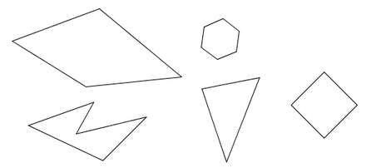
Regular polygon | Any polygon whose sides are all the same length and whose angles are all the same measure | 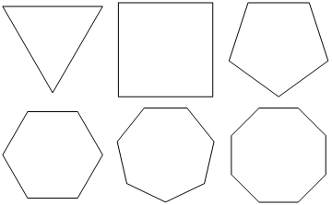
Irregular polygon | Any polygon whose sides are NOT all the same length and whose angles are NOT all the same measure | 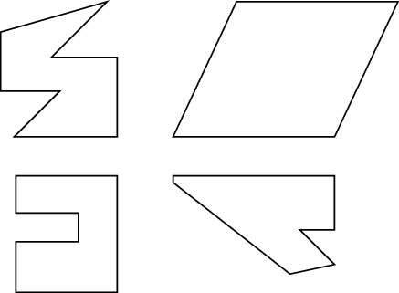
Triangle | A three-sided polygon
Quadrilateral | A four-sided polygon
Pentagon | A five-sided polygon
Hexagon | A six-sided polygon
Heptagon | A seven-sided polygon
Octagon | An eight-sided polygon
Nonagon | A nine-sided polygon
Decagon | A ten-sided polygon

Lesson 1: Classifying triangles by length
When classifying triangles by length, they are described as being scalene (no sides have the same length), isosceles (two angles have the same length) or equilateral (all three angles are the same length).
1) Classify the following angles by length.
A) 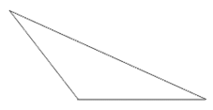 B) 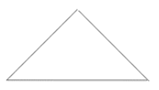

C) D) 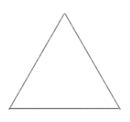

E) 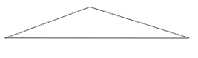 F) 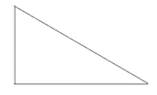

Lesson 2: Classifying triangles by angle
When classifying triangles by angle, they are described as being acute (all three angles are less than 90°), right (one angle measures exactly 90°), obtuse (one angle measures more than 90°) or equiangular (all three angles measure the same length).

1) Classify the following angles by angle.

A) B)

C) D)

E) F)

Lesson 3: Constructing triangles by angle
1) Using a protractor, construct the following triangles. Classify each triangle as either acute, right or obtuse.
A) 25° and 75° B) 40° and 110°

C) 50° and 50° D) 130° and 20°

E) 10° and 90° F) 30° and 95°

Lesson 4: Classifying polygons
1) Identify the type of polygon (ex. triangle, quadrilateral, etc.) and whether it is regular or irregular.
A) 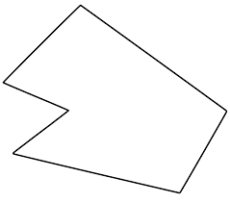 B)
C) 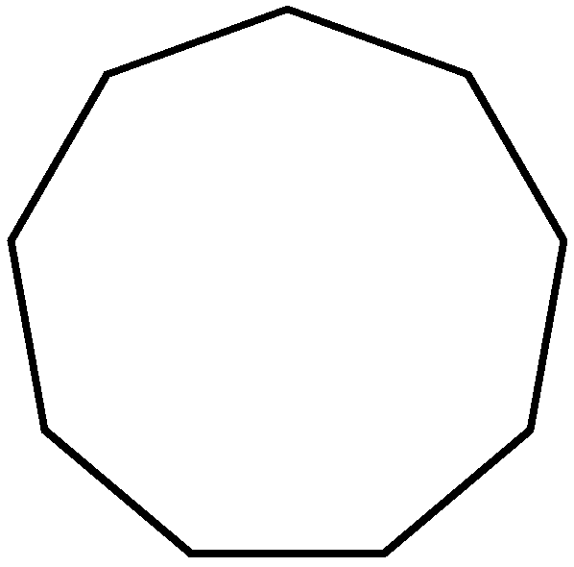 D) 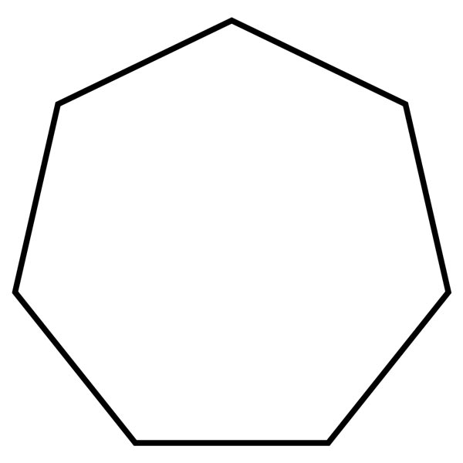
E) 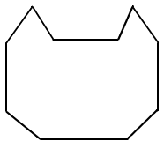 F) 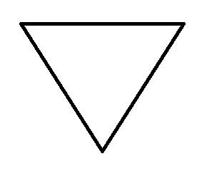

Lesson 5: Congruent polygons
Two polygons are congruent to one another if they have the same angles and side lengths.
1) Using tracing paper, determine if the following shapes are congruent or not.
A)

B)

C)

D)

2) Determine if the following shapes are congruent or not by measuring the angles and side lengths.
A)

B)

C)

D)

