Probability Project
By: _______________________________________________________
For this experiment, you will create and complete a probability experiment in groups of 2-3. Theoretical probability is the theoretical likelihood of an event occurring. For example, if you flip a coin 10 times, it should land on heads 5 times and tails 5 times. Experimental probability is what actually occurs when an event is tested.
1. Create a probability experiment. You may use spinners, dice, coloured blocks or a coin. Explain your project below. ______________________________________________________________________________
______________________________________________________________________________
______________________________________________________________________________
______________________________________________________________________________
______________________________________________________________________________
2. Determine the theoretical probability of the event occurring. Keep in the mind the formula for theoretical probability:
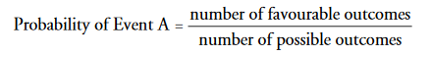
3. Perform the probability experiment 100 times. Tally the results below.

4. Determine the difference (if any) between the theoretical probability and the experimental probability. In order to do so, divide the predicted outcome by the actual outcome.

