Grade 6 Math NAME: _____________________________
Review
1) Solve the following equations using long division.
A) 249 ÷ 3 | B) 434 ÷ 7

2) What are the first six multiples of the following numbers?
A) 4 __________________________________________________________
B) 7 __________________________________________________________
3) Alex says that 48 is a multiple of 4. Is he correct? Show your workings.

4) Using the number line below, determine the common multiples of 3 and 4 from 0 to 20.

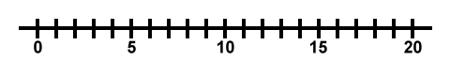
5) Brooklyn is buying chocolate bars and gum for her birthday party. Chocolate bars come in packs of 6 and gums come in packs of 4. If she invited 24 friends to her party, can she buy enough of each for everyone without having any left over?

6) Mr. Ezekiel tells all of the boys and girls in his gym class to line up in a straight line. Every second student in line is a girl. Every third student in line is wearing jogging pants. Every fifth student in line is wearing glasses. If there are 30 students in the class, how many girls are wearing jogging pants and glasses?
7) Use arrays to find the factors of 28.

8) Use a factor rainbow to determine the factors of 64.

