Grade 6 Math
Unit 5: Data Management

Name: ____________________________

Lesson 1: The Cartesian Plane
In unit 4, students were introduced to plotting points on a coordinate grid, also known as the Cartesian plane. When both coordinates are positive numbers, that point is found in the first quadrant of the Cartesian plane, as shown in the image below.
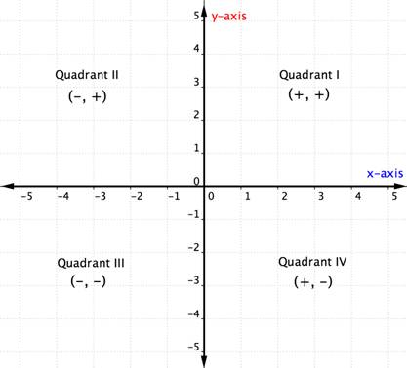
It is important to remember that the x-axis is horizontal (side to side) while the y-axis is vertical (up and down). The point at which these two lines intersect (0,0) is called the origin. When writing an ordered pair, the first number represents horizontal distance from the origin and second number represents the vertical distance from the origin. For example, in the grid on the following page, point A is found at (1, 9), not (9,1).

1) Write the coordinates for the points on the grid below.
B) __________ C) __________ D) __________
E) __________ F) __________
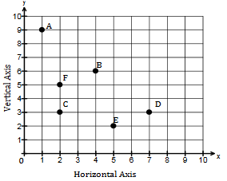
2A) Find the letter which corresponds to the following coordinates. What word does it spell?
(6,2), (3,0), (9,9), (5,5), (0,5), (3,0), (2,6)
_______________________________________
2B) Write your own word using coordinates and share with a friend.
_____________________________________________________________________________________
_____________________________________________________________________________________
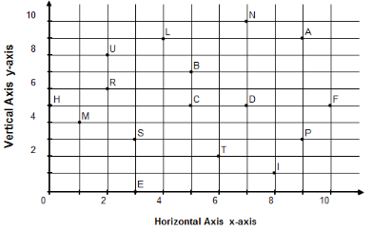
Lesson 2: Scale and the Cartesian Plane
Up until now, students have used intervals of 1 when labelling a Cartesian plane. This is also known as the scale. In the image below, note how the numbers increase by an interval (scale) of 1.
When dealing with larger coordinates, a scale of 1 may not always be appropriate given the size of the grid. For example, if a student wished to plot (16, 22), a scale of 2 would be more appropriate.
1) Label the following grids using an appropriate scale in order to plot each point.
A) (4, 18)
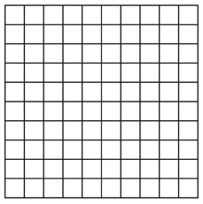

B) (25, 40)

C) (30, 100)

Lesson 3: Determining distance between points on a graph
The simplest way to determine the distance between two points on a graph is by counting the number of units (squares) between the two points. Remember to consider the scale when counting the units. For example, if a graph has a scale of 4 and there are 3 units between two points, then the distance between the two points is 12 (4 x 3 = 12).
1A) What are the coordinates of point A? ____________ Point B? ____________
1B) What is the scale of this graph? ____________
1C) What is the distance between the two points? ____________

2A) What are the coordinates of point S? ____________ Point T? ____________
2B) What is the scale of this graph? ____________
2C) What is the distance between the two points? ____________

3A) Plot points (15, 25) and (45, 25) on this graph.
3B) What is the scale of this graph? ____________
3C) What is the distance between the two points? ____________

4A) Plot points (9, 12) and (24, 12) on this graph.
3B) What is the scale of this graph? ____________
3C) What is the distance between the two points? ____________

Lesson 4: Analyzing information on line graphs
All line graphs share certain characteristics. Examine the following two line graphs. What do they have in common?
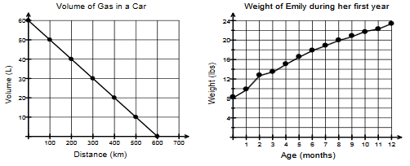
1) ____________________________________________________
2) ____________________________________________________
3) ____________________________________________________

4) Answer the following questions based on the graph “Volume of Gas in a Car.”
A) What is the title? ____________________________________________________________________
B) What is the x-axis labelled? ____________________________________________________________
C) What is the y-axis labelled? ____________________________________________________________
D) What is the scale of the x-axis? _______________
E) What is the scale of the y-axis? _______________
F) Based on the information provided on the graph, what do we know happened to the volume of gas as distance increased?
_____________________________________________________________________________________
_____________________________________________________________________________________

5) Answer the following questions based on the graph “Weight of Emily during her first year.”
A) What is the title? ____________________________________________________________________
B) What is the x-axis labelled? ____________________________________________________________
C) What is the y-axis labelled? ____________________________________________________________
D) What is the scale of the x-axis? _______________
E) What is the scale of the y-axis? _______________
F) Based on the information provided on the graph, what do we know happened to Emily’s weight as the months increased?
_____________________________________________________________________________________
_____________________________________________________________________________________

Lesson 5: Line graphs and scatter plots
Line graphs can use either continuous data (which can include any value between data points) while or discrete data (when the data between points has no meaning). Why do you think that continuous data was used for the first graph and discrete data for the second?
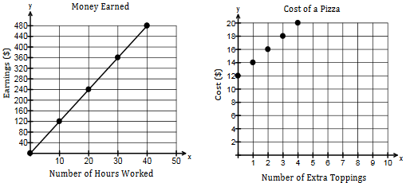

_____________________________________________________________________________________
_____________________________________________________________________________________
_____________________________________________________________________________________

- Plot the following data on the graph below. Do the following:
A) Add a title
B) Label the axes
C) Choose an appropriate scale for the x and y axes
D) Determine whether or not to use a line graph or scatter plot
Number of tickets purchased | 1 | 2 | 3 | 4 | 5
Cost ($) | 20 | 40 | 60 | 80 | 100

E) Explain your decision to use either continuous or discrete data.
_____________________________________________________________________________________
_____________________________________________________________________________________
_____________________________________________________________________________________
F) Based on the data and the graph, what conclusion can you draw about the relationship between the two variables (number of tickets purchased and cost)?
_____________________________________________________________________________________
_____________________________________________________________________________________
____________________________________________________________________________________
G) How much will six tickets cost?
___________________________________________
- Plot the following data on the graph below. Do the following:
A) Add a title
B) Label the axes
C) Choose an appropriate scale for the x and y axes
D) Determine whether or not to use a line graph or scatter plot
Minutes using iPad | 0 | 10 | 20 | 30 | 40
Battery life remaining | 100 | 90 | 80 | 70 | 60

E) Explain your decision to use either continuous or discrete data.
_____________________________________________________________________________________
_____________________________________________________________________________________
_____________________________________________________________________________________
F) Based on the data and the graph, what conclusion can you draw about the relationship between the two variables (minutes using iPad and remaining battery life)?
_____________________________________________________________________________________
_____________________________________________________________________________________
_____________________________________________________________________________________
G) How much battery life will remain after 50 minutes of use?
_________________________________________________
Lesson 6: Patterns and Relationships
1A) Complete the table of values below based on the pattern below.
Day 1 Day 2 Day 3
Day | 1 | 2 | 3 | 4 | 5
Number of apples sold
1B) Complete the graph below based on the table of values. Do the following:
i) Add a title
ii) Label the axes
iii) Choose an appropriate scale for the x and y axes
iv) Determine whether or not to use a line graph or scatter plot
1C) Explain your decision to use either continuous or discrete data.
_____________________________________________________________________________________
_____________________________________________________________________________________
_____________________________________________________________________________________

2A) Complete the table of values below based on the pattern below.
Day 3 Day 6 Day 9
Day
Number of bananas sold
2B) Complete the graph below based on the table of values. Do the following:
i) Add a title
ii) Label the axes
iii) Choose an appropriate scale for the x and y axes
iv) Determine whether or not to use a line graph or scatter plot
2C) Explain your decision to use either continuous or discrete data.
_____________________________________________________________________________________
_____________________________________________________________________________________
_____________________________________________________________________________________

Lesson 7: Line graphs vs. bar graphs
As you have seen, line graphs are used to demonstrate change. For example, a line graph would be used to demonstrate a student’s grades in math over the course of a semester, a child’s height over the course of a year or the price of movie tickets.
Bar graphs are used to display data grouped into categories. For example, students favourite movie genre or, as in the example below, how students get to school.
Bus | 15
Walk | 4
Dropped-off | 9

1) Place the following data on a bar graph. Do the following:
A) Add a title
B) Add a label for each of the categories
C) Determine an appropriate scale
D) Plot the data
Strawberries | 10
Bananas | 6
Oranges | 5
Apples | 7

E) Why was a bar graph more appropriate than a line graph in this case?
_____________________________________________________________________________________
_____________________________________________________________________________________

