Grade 6 Math NAME: _______________________
Unit 8 Review
1A) What is the ratio of balloon dogs to real dogs?
In numbers: __________
In words: _____________________________________________________________________
1B) What is the ratio of real dogs to balloon dogs?
In numbers: __________
In words: _____________________________________________________________________
1C) What is the ratio of balloon dogs to all dogs?
In numbers: __________
In words: _____________________________________________________________________
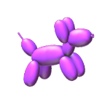
2) Make a drawing to represent the following ratios.
A) 4:3

B) 5:2
3) Determine whether or not the following ratios are equivalent to one another. Write “equivalent” or “not equivalent” on the line.
A) 2:3 and 4:6 ________________________________________________
B) 3:1 and 6:3 ________________________________________________
C) 2:5 and 6:15 ________________________________________________
D) 4:3 and 8:5 ________________________________________________
E) 1:7 and 2:12 ________________________________________________
4) Make an equivalent ratio for the following ratios.
A) 2:5 __________________
B) 5:3 __________________
C) 7:4 __________________
5) Express the following ratios as fractions.
2:5

5:3

1:7

6) Express the following fractions as ratios.
$$\frac{3}{4}$$

$$\frac{4}{5}$$

$$\frac{9}{5}$$

7) Complete the chart below.
Fraction | Ratio | Percentage | Decimal
$$\frac{8}{100}$$

 | 27:100
 |  | 90%
 |  |  | .59

8) Place the following sets of numbers on the number line.
A)
.7 | $$\frac{29}{100}$$ | 7:100 | 150:100 | 88%

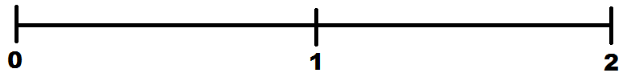

9) Students at Hazelwood Elementary raised $500 for the band program. Mr. Burry decides to spend 40% on new instruments, 35% on a new sheet music and 25% on a fancy new conductor’s baton. How much money was spent on each?

10) Ms. Sinnott and Ms. Ward are bring 25 bags of groceries for the Breakfast Club into the school. If Ms. Sinnott brings in $\frac{6}{10}$ of the groceries, how many bags did she bring in?

