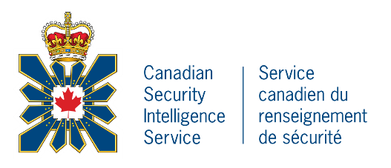
CANADIAN SECURITY INTELLIGENCE SERVICE
SERVICE CANADIEN DU RENSEIGNEMENT DU SÉCURITÉ

COUNTRY NAME: CANADA
GOVERNMENT TYPE: CANADA IS A CONSTITUTIONAL MONARCHY WHICH IS A FORM OF DEMOCRACY.
LEADER: CANADA’S PRIME MINISTER IS JUSTIN TRUDEAU. MR. TRUDEAU WAS BORN IN OTTAWA, ONTARIO, CANADA ON DECEMBER 25TH, 1971.
LEADERSHIP DETAILS: JUSTIN TRUDEAU WAS OVERWHELMINGLY ELECTED PRIME MINISTER IN 2015 IN FREE AND OPEN DEMOCRATIC ELECTIONS.
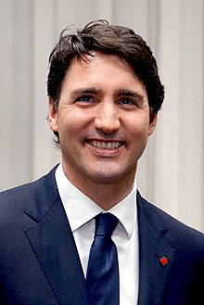
LIVING CONDITIONS IN COUNTRY: ACCORDING TO HUMAN RIGHTS WATCH, “CANADA ENJOYS A GLOBAL REPUTATION AS A DEFENDER OF HUMAN RIGHTS.” CANADA’S CHARTER OF RIGHTS AND FREEDOMS PROTECTS THE CIVIL AND POLITICAL RIGHTS OF ALL CANADIANS. CANADA IS ONE OF THE WORLD’S RICHEST NATIONS. CANADIANS HAVE ACCESS TO MEDIA WHICH PRESENTS A VARIETY OF OPINIONS. HOWEVER, CANADA CONTINUES TO STRUGGLE WITH HUMAN RIGHTS ISSUES RELATED TO THE TREATMENT OF THE COUNTRY’S INDIGINEOUS POPULATION.
